**Internal RTC in ESP32 vs External RTC Modules: A Comprehensive Comparison**

**1. ESP32 Internal RTC**

**Overview:**

The ESP32 has an in-built **Real-Time Clock (RTC)** within its Ultra-Low-Power (ULP) co-processor, enabling basic timekeeping functionality. It operates even in **deep sleep mode** and is suitable for many low-power IoT applications.

**Features:**

* **Basic Timekeeping**:
  + Tracks seconds, minutes, hours, and days.
  + Can maintain time during sleep modes.
* **Wake-Up Timer**:
  + Configurable alarms and timers to wake up the ESP32 from sleep.
* **Low Power Consumption**:
  + The RTC is part of the ULP subsystem and consumes minimal power during deep sleep (~2.5 µA in RTC-only mode).

**Advantages:**

1. **Cost**:
   * No additional hardware cost, as the RTC is built-in.
2. **Compact Design**:
   * Reduces the need for external components, ideal for small, space-constrained devices.
3. **Power Efficiency**:
   * Operates in ultra-low power mode during deep sleep, saving battery in IoT applications.
4. **Integration**:
   * Works seamlessly with ESP32’s deep sleep and wake-up mechanisms.

**Disadvantages:**

1. **Accuracy**:
   * Subject to clock drift due to environmental factors (e.g., temperature changes).
   * Drift can be significant over long periods without synchronization (~5–10 seconds per day).
2. **Reliability**:
   * No battery backup. If the ESP32 loses power, the RTC resets, and you’ll need to re-synchronize it.
3. **Limited Precision**:
   * Not suitable for high-precision time-sensitive applications.

**Best Use Cases:**

* **Battery-Powered IoT Devices**:
  + Sleep/wake cycles based on intervals (e.g., sensor data logging every 15 minutes).
* **Short-Term Timekeeping**:
  + Applications that don't need accurate time over weeks or months (e.g., power cycling or sensor calibration).
* **Internet-Connected Devices**:
  + Devices that synchronize time regularly using NTP servers (e.g., smart home devices).

**Example:**

A **temperature and humidity sensor** using an ESP32 might log data every 10 minutes. The internal RTC can track time and wake the ESP32 from deep sleep for data collection, saving power.

**2. External RTC Modules**

**Overview:**

External RTC modules, such as the **DS3231**, **DS1307**, or **PCF8563**, are dedicated hardware components designed for accurate timekeeping. They are equipped with backup power options (e.g., a coin cell battery) and advanced features like alarms, temperature compensation, and calibration.

**Features:**

* **High Accuracy**:
  + Modules like the DS3231 have temperature-compensated crystal oscillators (TCXOs) to minimize drift (±2 ppm or ~1 minute/year).
* **Battery Backup**:
  + Most external RTCs have a CR2032 or similar battery to maintain time during power outages.
* **Extended Calendar Functions**:
  + Includes tracking of seconds, minutes, hours, days, weeks, months, years, and leap years.
* **Interface**:
  + Communicates via I2C or SPI, making it easy to integrate with microcontrollers.

**Advantages:**

1. **Accuracy**:
   * Significantly more reliable over long periods than the ESP32 internal RTC.
2. **Persistence**:
   * Maintains time even when the main device loses power.
3. **Flexibility**:
   * Some modules support advanced alarm features and timestamping for events.
4. **Standalone Operation**:
   * Can function independently of the ESP32 or other controllers.

**Disadvantages:**

1. **Cost**:
   * Adds ~$1–$5 to the BOM (Bill of Materials) depending on the module (e.g., DS1307 is cheaper, DS3231 is more expensive).
2. **Power Consumption**:
   * Typically consumes more power than the ESP32 internal RTC, especially in always-on mode.
3. **Complexity**:
   * Requires additional wiring, code libraries, and PCB space.

**Best Use Cases:**

* **Long-Term Timekeeping**:
  + Projects requiring accurate time for weeks, months, or years without external synchronization.
* **Offline Systems**:
  + Devices that cannot synchronize with NTP servers or the internet.
* **Data Logging**:
  + Applications requiring precise timestamps (e.g., environmental monitoring, industrial systems).

**Example:**

A **weather station** that logs data every hour and operates in a remote area without internet access could use a DS3231 for accurate timekeeping and event scheduling.

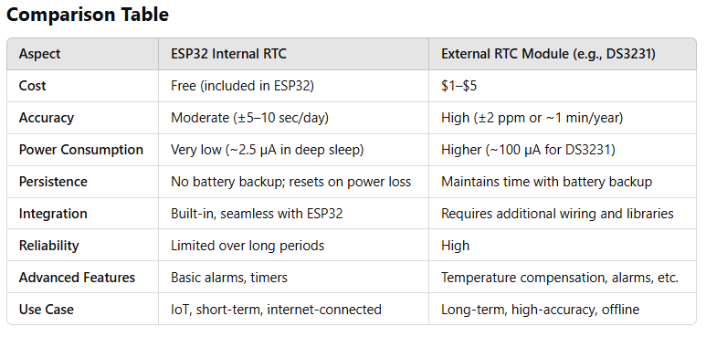

**Which One to Use?**

1. **Use ESP32 Internal RTC When**:
   * Cost and simplicity are critical.
   * The system connects to the internet for periodic NTP synchronization.
   * The application has short timekeeping requirements.
   * Power efficiency is a priority, such as in battery-powered IoT devices.
2. **Use External RTC When**:
   * Accurate and persistent timekeeping is required.
   * The device operates in an offline environment.
   * Long-term data logging or scheduling is necessary.
   * Applications cannot tolerate clock drift (e.g., industrial systems or scientific measurements).